Write a map reduce program to desing a custom counter to count number of people are affected with 'PULMONARY' disease and 'BRONCHITIS & ASTHMA' in the state 'CA'.

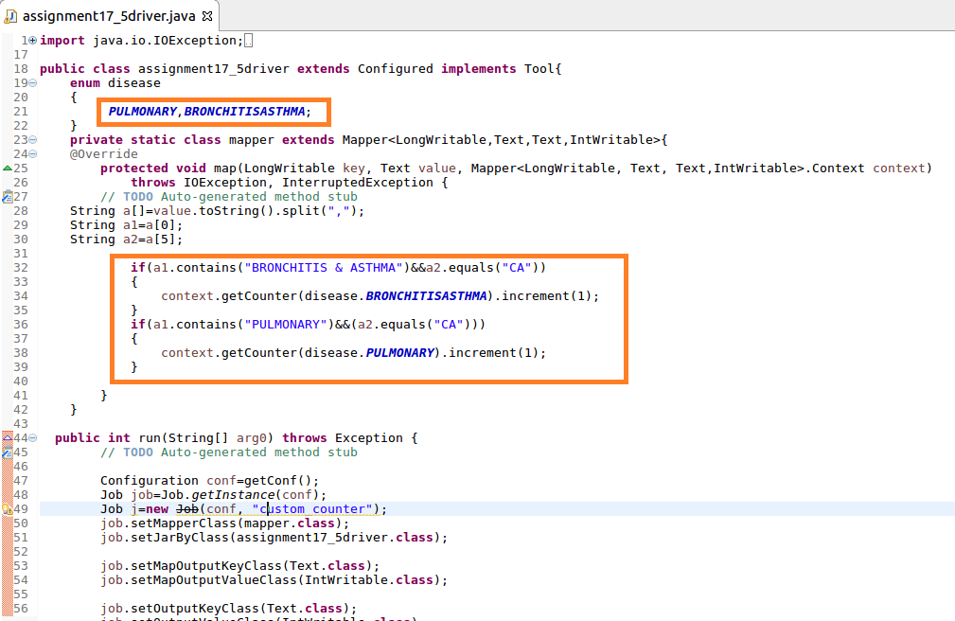

custom counter BRONCHITIS and PULMONARY have been created and incremented by 1

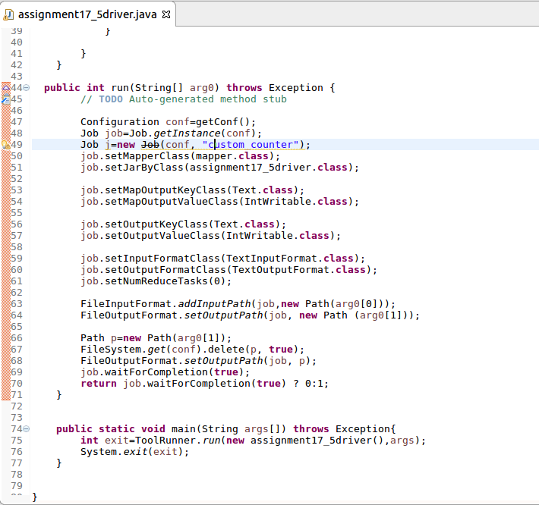

RUNNING JAR:

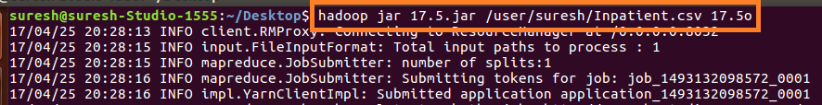

OUTPUT:

